LCM Test Tool User Guide

Document Information
abstract | The LCM Test Tool is the convenient tool to light on the LCM rapidly. It can export the dedicated text file to integrate with the same driver for different LCM, respectively. This document instructs the user how to use the tool smoothly.
Apply to | N9H2x Series

The information described in this document is the exclusive intellectual property of
Nuvoton Technology Corporation and shall not be reproduced without permission from Nuvoton.

Nuvoton is providing this document only for reference purposes of NuMicro microcontroller based system design. Nuvoton assumes no responsibility for errors or omissions.
All data and specifications are subject to change without notice.

For additional information or questions, please contact: Nuvoton Technology Corporation.
www.nuvoton.com

Table of Contents
1 Overview 3
1.1 USB Booting in Recovery Mode 3
1.2 LCM Test Tool Introduction 3
2 Function Description 4
2.1 Starting to Use LCM Test Tool 4
2.2 Download Image 5
2.3 LCM Option Setting 6
2.4 Sync LCM Option 12
2.5 MPU LCM Option 19
2.6 Set LCM Internal Registers 22
2.7 Save and Export Setting File 23
2.8 Load Exported File 24
3 Application Example 25
4 Revision History 27

Overview

USB Booting in Recovery Mode
The N329/N9H2X series has two boot flows – one is the Normal Mode and the other is Recovery Mode. To use LCM Test Tool from USB booting, the N9H2X device should be set to the Recovery Mode. During USB booting, the N9Hxx related firmware for LCM Test Tool will be loaded to DRAM from USB. The main purpose of firmware is to decode the USB vendor command for LCM initial settings.

LCM Test Tool Introduction
The LCM Test Tool is a convenient tool to check whether the LCM related initial settings to be well or not. The settings have been passed to the DRAM by USB and verified rapidly by the corresponding firmware. After getting the exact image displayed on the LCM, these settings can be exported and saved as a text file. The LCM driver can take advantage of the file contents to light on the LCM successfully. In the VPOST sample code, it provides an example to instruct how to use the file exactly.

Here some files within the LCM Test Tool folder have been described below.

- [LCM Test Tool Version History – ChangeLog.txt]
All LCM Test Tool and firmware change history are listed in this file.
- [LCM Test Tool program – LCMTest.exe]
The PC-based tool execution file.
- [LCM Test Tool Configuration for Boot Code Header – LCMTest.ini]
The IBR program supports some user-defined items in boot code header, including boot code executing address, DRAM clock skew settings, register writing function, and delay function. After confirming the flash content is for booting, the IBR will do corresponding operation according to the boot code header information.
- [N9H2x_musb.bin]
The LCM Test Tool can load the firmware (N9H20_musb.bin or N9H26_musb.bin) from PC to N9H2X series by USB boot. After booting, it can be executed in N9H2x device.
- [default setting – Option.ini]
This file stores the default settings for the tool.
- [LCM register settings – Register.ini]
The file stores the default settings for LCM internal regsiter.

Function Description

Starting to Use LCM Test Tool

When to begin opening the tool, the connected device must be selected first. The available devices consist of N9H20K5, N9H20K3, N9H20K1 and N9H26.

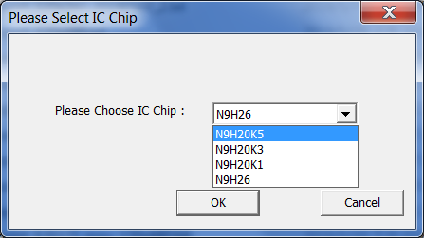

After the device selected from the dialog, the tool will try to connect the target board automatically. Before to do other selection, please make sure the board being connected.

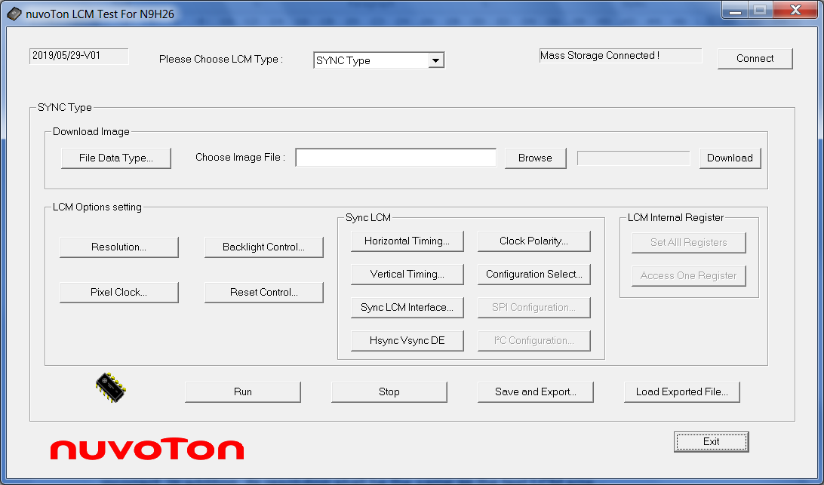

Download Image
The tool supports the raw data image file and its data type shall be given at the same time. If the selected data type is different from the image contents, the displayed image will be incorrect. In addition, its resolution shall be the same as the test LCM size.

Before to download the test image, the file data type shall be selected from its dialog.

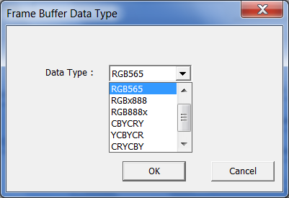

Then the image fle can be browsed and selected from the disk. Specifically, the image file must be a raw one with binary format.
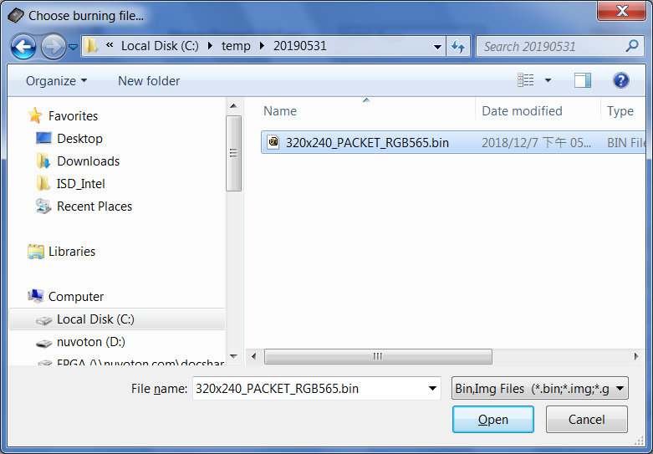

After the file being selected, click the button “Download” and then get the information of “Downloaded successfully”

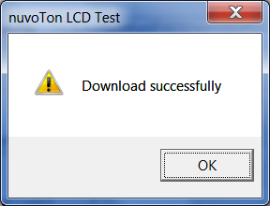

LCM Option Setting
Several options listed below must be set for both the sync and MPU LCM.
- [Set LCM Type]

Two knids of LCM type can be selected, including “SYNC Type” and “MPU Type”.From the dialog, please select the LCM type.

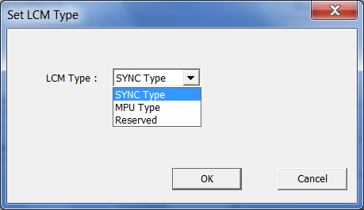

- [LCM Resolution]

The resolution must be given to match with the tested LCM. The exact settings are given in the “LCM Resolution” window.

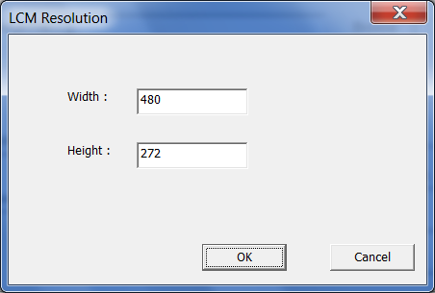

- [Pixel Clock Frequency]

Set the pixel clock in the “Pixel Clock” window and its clock base is KHz.

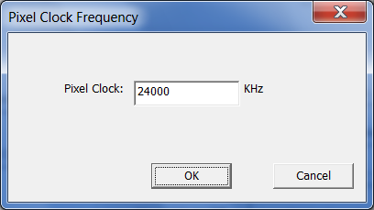

- [Backlight Control]

In the backlight control circuit, sometimes it needs “Ena” or “PWM” or both control signals. For example, the following application circuit for ZT7418 LED driver needs to set “Ena” and “FB” ports for backlight control.

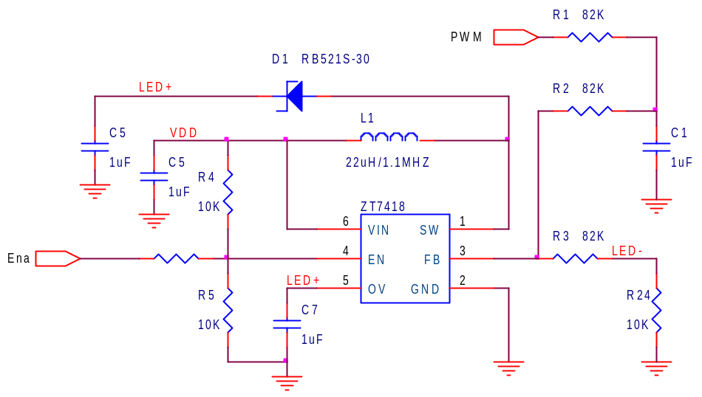

The user can use this option to control “Ena” and “PWM” ports properly.

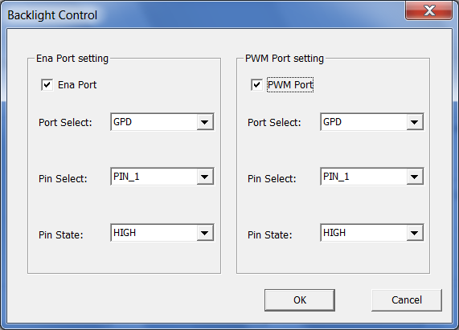

- [Reset Control]

This tool also provides the LCM reset control option. If the LCM reset pin is connected to the board reset directly, this option can be neglected and not selected.

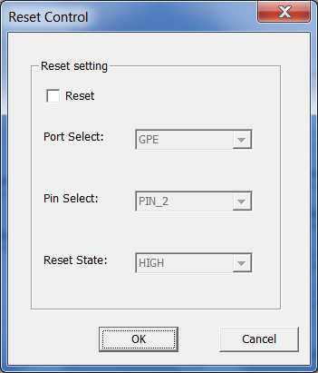

Sync LCM Option
Several options are dedicated to the sync type LCM and listed below.
- [Horizontal Timing]

For the horizontal timing, this tool provides three settings with the times of pixel clock cycles, including
- HSPW: horizontal sync pulse width
- HBPD: horizontal back porch duration
- HFPD: horizontal from porch duration

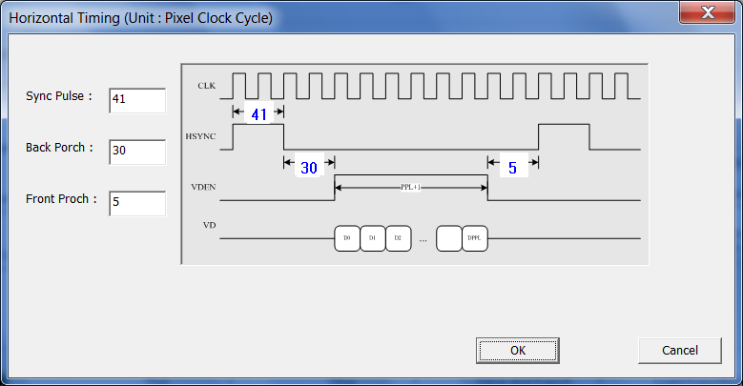

- [Vertical Timing]

For the vertical timing, this tool provides three settings with the times of scanning lines, including
- VSPW: vertical sync pulse width
- VBPD: vertical back porch duration
- VFPD: vertical from porch duration

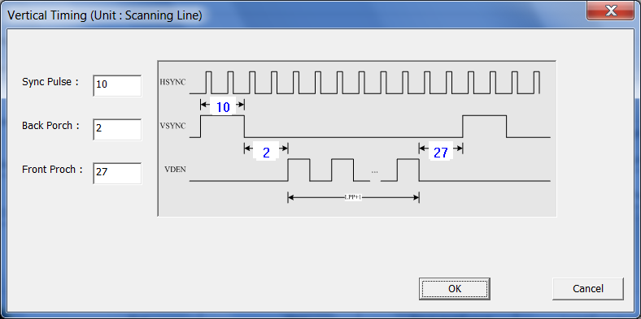

- [Sync LCM Interface]

In the sync type LCM, it may use the different interfaces to receive image data, including RGB565, RGB888, CCIR656, CCIR601 and so on. This tool can support most interfaces for the sync type LCM.

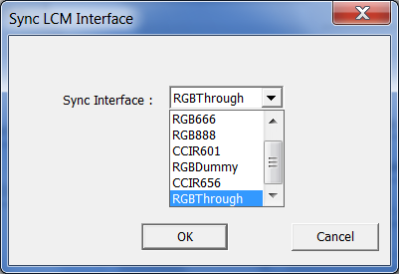

- [Clock Polarity]

As for several sync clocks, this tool also provide the polarity settings.

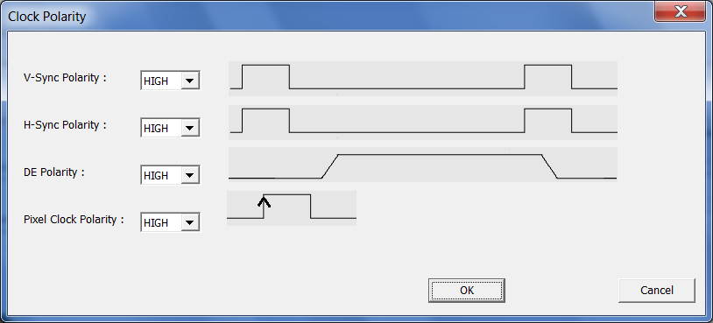

- [Configure Interface]

In some LCMs, their internal registers must be configured in advance and usually the selected interface is the SPI interface. Therefore, this tool provides the SPI interface for LCM register configuration.

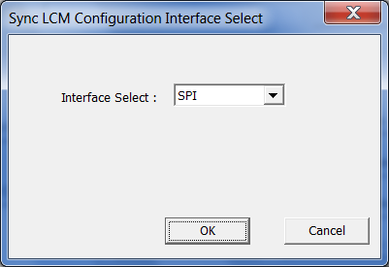

- [SPI Configuration]

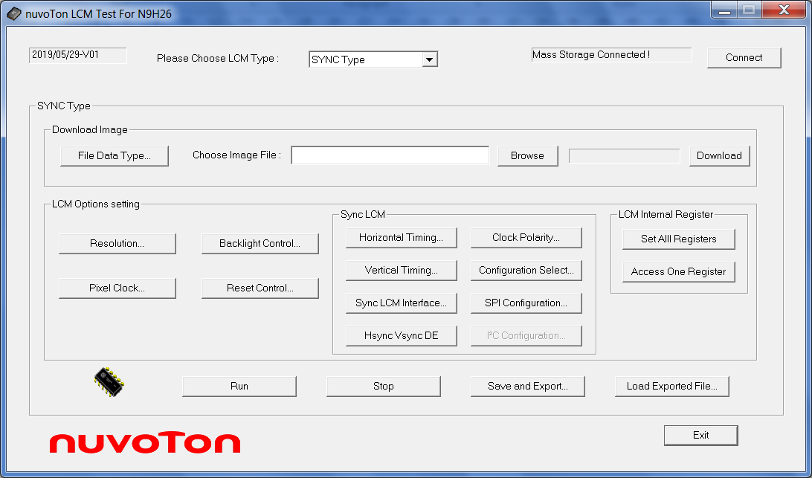

If the SPI interface is selected in “Configure Interface”, we can set the SPI port, register index and data width.

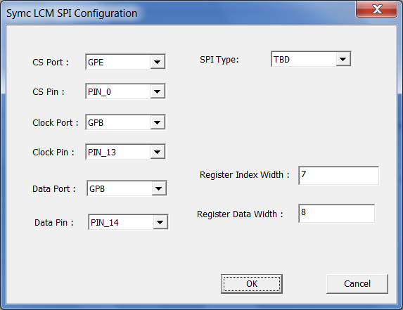

- [Hsync Vsync DE Mode]

In the different sync type LCMs, they may need different sync signals, for example, “Hsync+Vsync+DE” or “Hsync+Vsync” or “DE_only”. This tool provides the option to be selected.

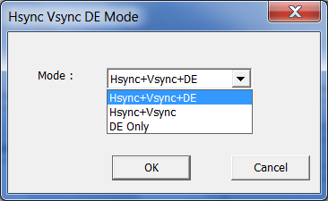

MPU LCM Option
In MPU LCM, both the MPU interface and internal reigisters must be given. The interface is introdiced in this section. As for how to set the internal registers, it will be decribed in the next section.

- [MPU LCM Interface]

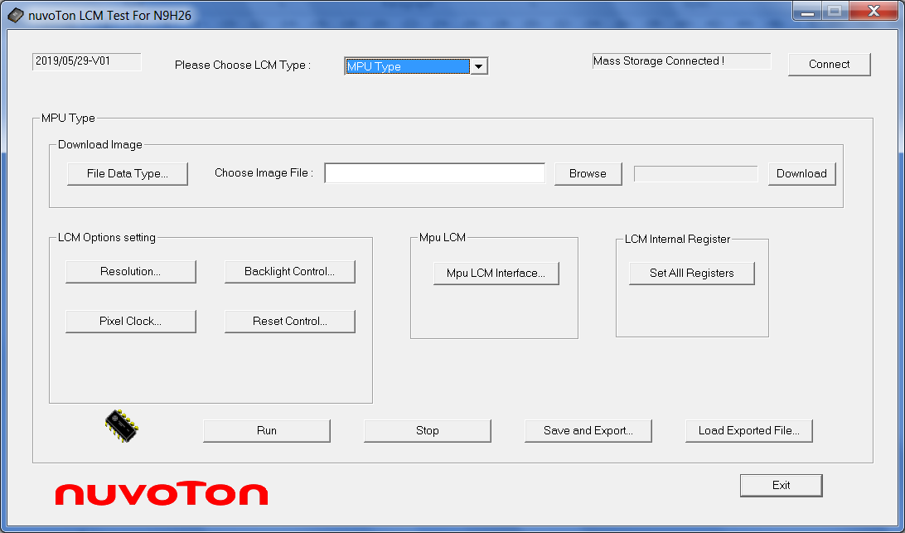

This tool provides several MPU interfaces for selection.

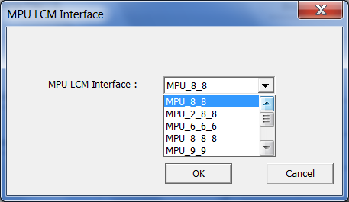

In different MPU LCM interfaces, mainly they are diferent from the data bus width and read/write cycle numbers in each LCM register/graphic memory access. Here the table lists the data bus width and cycle number for different interfaces, respectively.

 | memory cell | bus width | 1st transfer | 2nd transfer | 3rd transfer
MPU_8_8 | 16-bit | 8-bit | 8 | 8 | x
MPU_2_8_8 | 18-bit | 8-bit | 2 | 8 | 8
MPU_6_6_6 | 18-bit | 6-bit | 6 | 6 | 6
MPU_8_8_8 | 24-bit | 8-bit | 8 | 8 | 8
MPU_9_9 | 18-bit | 9-bit | 9 | 9 | x
MPU_8_8 | 16-bit | 8-bit | 8 | 8 | x
MPU_16_2 | 18-bit | 16-bit | 16 | 2 | x
MPU_2_16 | 18-bit | 16-bit | 2 | 16 | x
MPU_16_8 | 24-bit | 16-bit | 16 | 8 | x
MPU_8_16 | 24-bit | 16-bit | 8 | 16 | x
MPU_18 | 18-bit | 18-bit | 18 | x | x
MPU_24 | 24-bit | 24-bit | 24 | x | x
x: means data not being sent at the time.

To interpret the table in more details, let we use the MPU_8_8 interface as an example. In MPU_8_8, from the table, we can know that each 16-bit memory access needs two times of 8-bit data transfer and its data bus is 8-bit width. Referring from ILI9325 LCD driver datasheet, Its AC timing waveform is given below.
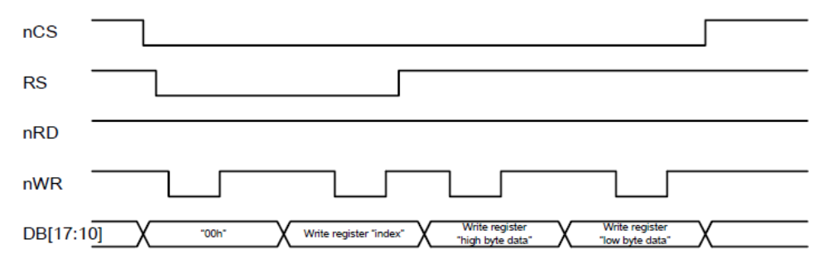

From the above waveform, it is easy to find total two times 8-bit WR cycles to finish 16-bit register access.

  - Set LCM Internal Registers
- [Set All Registers]

All MPU and some sync type LCMs need to configure internal registers. The tool can load the register setting file and its filename is register.ini. In register.ini, it is constructed by the register pair, {register index, register data}, that is, the first word is the register index and the sceond word is the register data, and so forth. The default regsiter.ini is for ILI9325 LCM.
Some specical cases for only to send register index or register data or add delay cycle between two reigster pairs, this tool provides the following methods to meet different requirements.

- only send reigster index but not regsiter data
In the register pair, the regsiter data is given by 0xFFCD, that is, {registe index, 0xFFCD}
- only send reigster data but not regsiter index
In the register pair, the regsiter index is given by 0xFFCC, that is, {0xFFCC, register data}
- add delay cycle
In the register pair, the regsiter index is given by 0xFFDD and the register data is the delay cycle. The delay cycle base is 10 mS.

Here is an example for the setting file.
lcm_reg[] = {
/* {RegIndex, RegData} */
{0x00CF, 0x0000},
{0x002C, 0xFFCD}, // 0xFFCD: register data need not send
{0xFFCC, 0x00C1}, // 0xFFCC: register index need not send
{0x00ED, 0x0064},
{0xFFDD, 0x0012}, // 0xFFDD: 10 mS delay cycle base; total delay 180 mS
};

Save and Export Setting File
- [Save and Export]

All tool settings can be exported and saved as a setting file, and it can be integrated with the LCM driver to light on the dedicated LCM. In general, the different LCMs shall have the different setting files. Based on the different setting files, we can use them to integrate with the same LCM driver for different LCMs, respectively.

Load Exported File
- [Load Exported File]

For different LCM, the different setting files also can be loaded in this tool, respectively.

Application Example

In VPOST sample code, it provides an example project “VPOST_N9H20_LCM” to instruct the user how to integrate with the setting file.

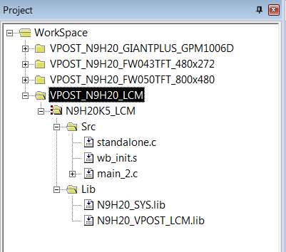

As for how to combine with the setting file, the procedure is listed below.
    - Use the tool to light on the target LCM.
    - After lighting on the LCM successfully, export the setting file and save it to the desired filename. For example, it is named as “export_GPM1006D_320x240.txt”.
    - In the application prorgam, please include the above file in an array. In main-2.c case, the arary name is Lcm_Initdata[]”.
    - Preapre another image raw data file and include it in another array in the application program. In main-2.c case, the arary name is “Vpost_Frame[]”.
    - Link wih LCM driver library N9H2x_VPOST_LCM.lib in the project file. For N9H20 or N9H26 device, N9H20_VPOST_LCM.lib or N9H26_VPOST_LCM.lib shall be linked, respectively.
    - Add N9HxxLCMInit() statement in the application program for LCM initialization. In main-2.c case, the N9HxxLCMInit((UINT32*)Vpost_Frame, (UINT8*)Lcm_InitData) statement is added in the main() function.

The sample code for LCM initialization is listed below and can also be found in main-2.c in N9H2x BSP.
__align(32) UINT8 Lcm_InitData[] = {
#ifdef __LCD_320x240__
#include "export_GPM1006D_320x240.txt" // exported file
#endif
}
__align(32) UINT8 Vpost_Frame[] = {
#ifdef __LCD_320x240__
#include "roof_320x240_rgb565.dat" // image data
#endif
}
int main(void) {
/* initialize LCM and display the image */
N9HxxLCMInit((UINT32*)Vpost_Frame, (UINT8*)Lcm_InitData);
}

Revision History

Date | Revision | Description
2019.05.13 | 1.00 | Initially issued.
2019.05.31 | 1.01 | Add N9H26 supported.

Important Notice
Nuvoton Products are neither intended nor warranted for usage in systems or equipment, any malfunction or failure of which may cause loss of human life, bodily injury or severe property damage. Such applications are deemed, “Insecure Usage”.
Insecure usage includes, but is not limited to: equipment for surgical implementation, atomic energy control instruments, airplane or spaceship instruments, the control or operation of dynamic, brake or safety systems designed for vehicular use, traffic signal instruments, all types of safety devices, and other applications intended to support or sustain life.
All Insecure Usage shall be made at customer’s risk, and in the event that third parties lay claims to Nuvoton as a result of customer’s Insecure Usage, customer shall indemnify the damages and liabilities thus incurred by Nuvoton.


